**23CCE284 DATABASE MANAGEMENT SYSTEMS LABORATORY**

**A Report on**

**ONLINE COURSE PORTAL**

A DBMS PROJECT

Submitted by

MEGHANA S R S

CB.EN.U4CCE23049



Department of Electronics and Communication Engineering,

Amrita School of Engineering,

Amrita Vishwa Vidyapeetham,

Coimbatore, India -641112.

**CONTENTS**

|  |  |  |
| --- | --- | --- |
| **SNO** | **TITLE** | **PAGE NO** |
| 1 | Objective | 1 |
| 2 | Abstract | 1 |
| 3 | Schema diagram | 2 |
| 4 | ER diagram | 3 |

**OBJECTIVES:**

1. User Management: Efficiently manage students, instructors, and admins with secure authentication and role-based access.

2. Course Management: Enable creation, organization, and categorization of courses with instructor assignments.

3. Enrollments: Track user enrollments, progress, and course completion status

4. Content Delivery: Structure lessons and modules for sequential access to various content types.

5. Assignments and Grading: Manage assignments, submissions, and grading efficiently.

6. Feedback and Reviews: Allow users to rate and review courses for quality improvement.

7. Payments: Track secure payments with status updates for course enrollments.

8. Notifications: Notify users of important updates, deadlines, or announcements.

9. Discussion Forums: Enable collaborative learning through course-specific forums.

10. Scalability and Security: Ensure database scalability, data integrity, and secure handling of sensitive information.

This ensures a robust and user-friendly online course platform.

**ABSTRACT:**

This project, Online Course Portal, aims to design and implement a robust and scalable database system to manage and facilitate e-learning. The portal provides a centralized platform for students, instructors, and administrators to interact seamlessly. The database design is built using a relational model and is normalized to ensure efficient data storage, retrieval, and management.

The system encompasses various functionalities supported by carefully designed tables:

1. User Management: Tracks user profiles, including students, instructors, and admins, with attributes like user type, contact details, and registration date.

2. Course Management: Stores comprehensive details about courses, their instructors, and associated metadata, allowing categorization by subject and topic.

3. Enrollment Tracking: Monitors user enrollments, course progress, and status updates.

4. Lesson and Assignment Modules: Organizes course content into lessons and tracks assignments and submissions, enabling structured learning.

5. Feedback and Ratings: Facilitates course reviews and ratings for quality

1

improvement.

6. Payment Processing: Ensures smooth transactions and tracks payment statuses for enrolled courses.

7. Communication and Community: Enables interaction through notifications and forum discussions for collaborative learning.

Additional tables like Subjects and Course Subjects support many-to-many relationships for flexible course categorization, ensuring courses can span multiple domains. The schema supports scalability, future enhancements, and optimized performance for data retrieval. This project demonstrates the practical implementation of relational database management principles and showcases how databases can support modern e-learning platforms effectively.

**SCHEMA DIAGRAM:**

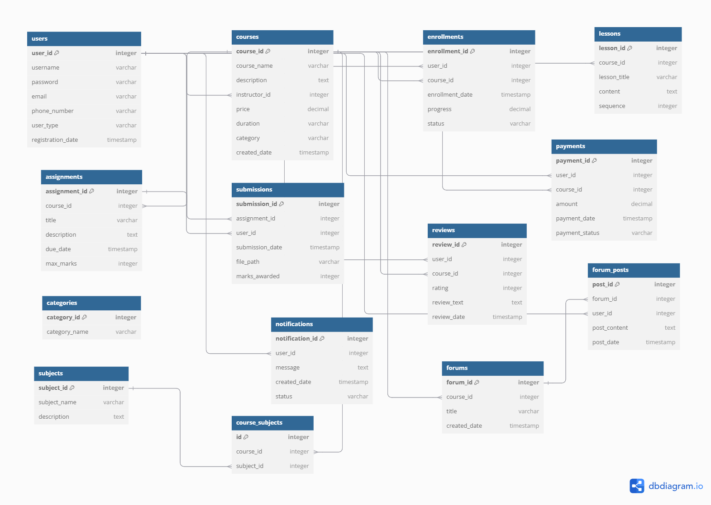

2

**E-R DIAGRAM:**

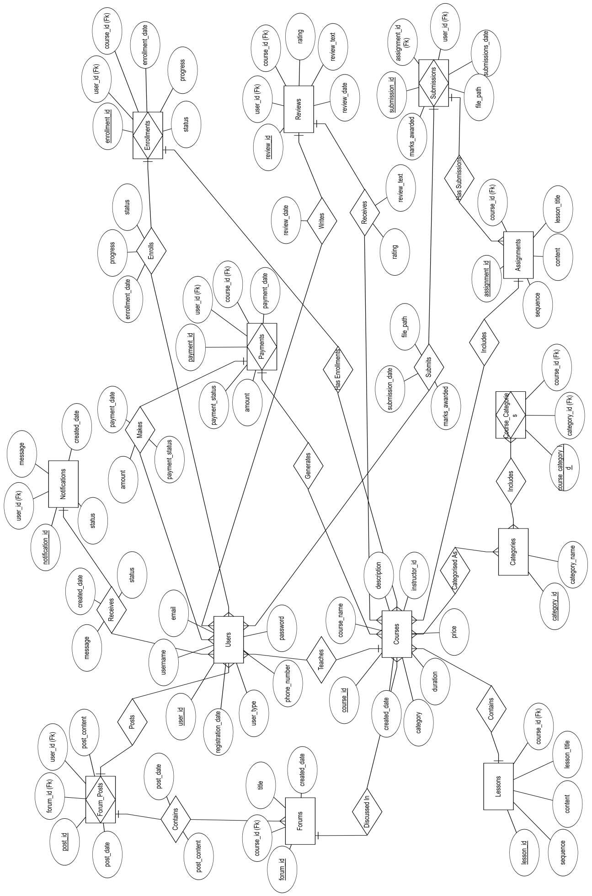

3